abstract template
Carbon release from the forest soils on the clear-cuts after the bark beetle infestation
Vít Šrámek¹⁾, Tomáš Čihák²⁾, Radek Novotný¹⁾
¹⁾ Forestry and Game Management Research Institute, Strnady 136, 252 02 Jíloviště, Czech Republic
²⁾ Czech University of Life Sciences, Kamýcká 129, 165 00 Praha 5 – Suchdol, Czech Republic

Text of the abstract, e.g: Central European forests face an unprecedented bark beetle infestation, which may change the future of our forests and forestry as well as that of the whole forest-based sector. While the public is highly worried being confronted with the expanding area of declining forests and clear-cuts, forest owners, foresters and state administration are overwhelmed by activities focused on tackling the current situation in the fields of forest protection, economy as well as timely and feasible reforestation. The situation is developing quickly, and vital decisions are taken in short time.
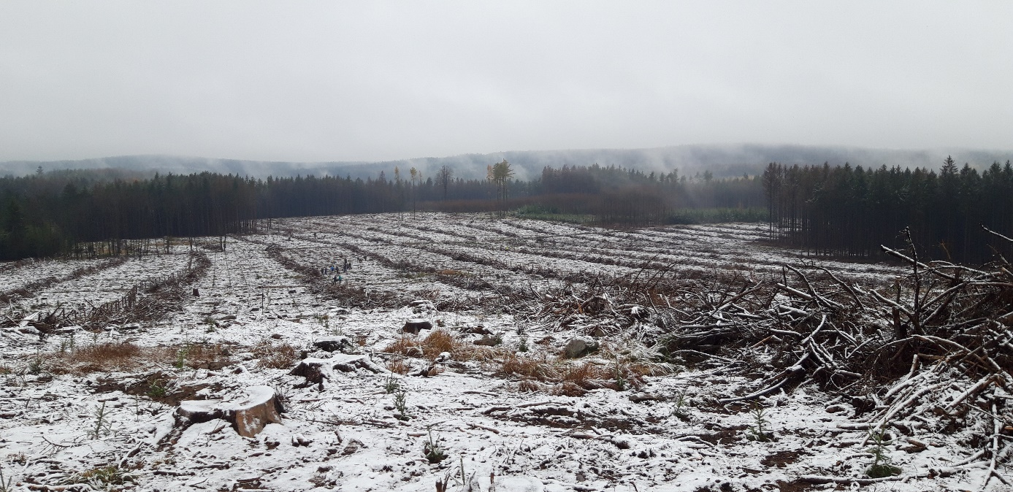
Fig.1: Clearcut in the Jihlava vincinity (figures, graphs or tables are allowed if needed)

References (if needed)
LOMSKÝ, B., ŠRÁMEK, V., NOVOTNÝ, R., 2012: Changes in the air pollution load in the Jizera Mts.: effects on the health status and mineral nutrition of the young Norway spruce stands. European Journal of Forest Research 131(3): 757-771

Acknowledgement: (if needed)
This work was supported by the project of the Ministry of Agriculture of the Czech Republic – Resolution RO0117 (reference number 6779/2017-MZE-14151).

